Teen Book Fiends
The 7th and 8th graders in this collaborative book club met for the first time face-to-face in early February. Danforth scholars traveled to visit the Ed Smith scholars.
We started with a form of “Boggle” using students own names at the tables in the library. You can see a copy of Bang by Sharon G. Flake on the table. It was the first book they read.
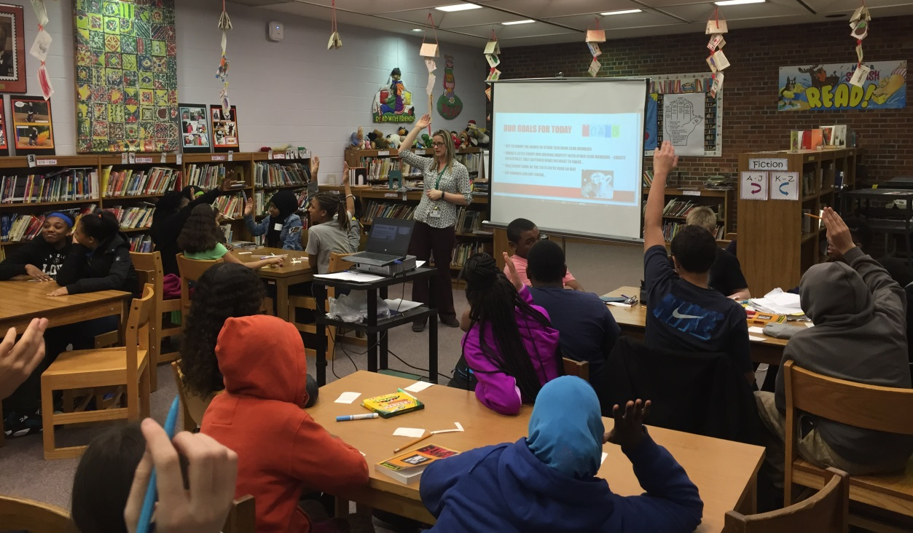
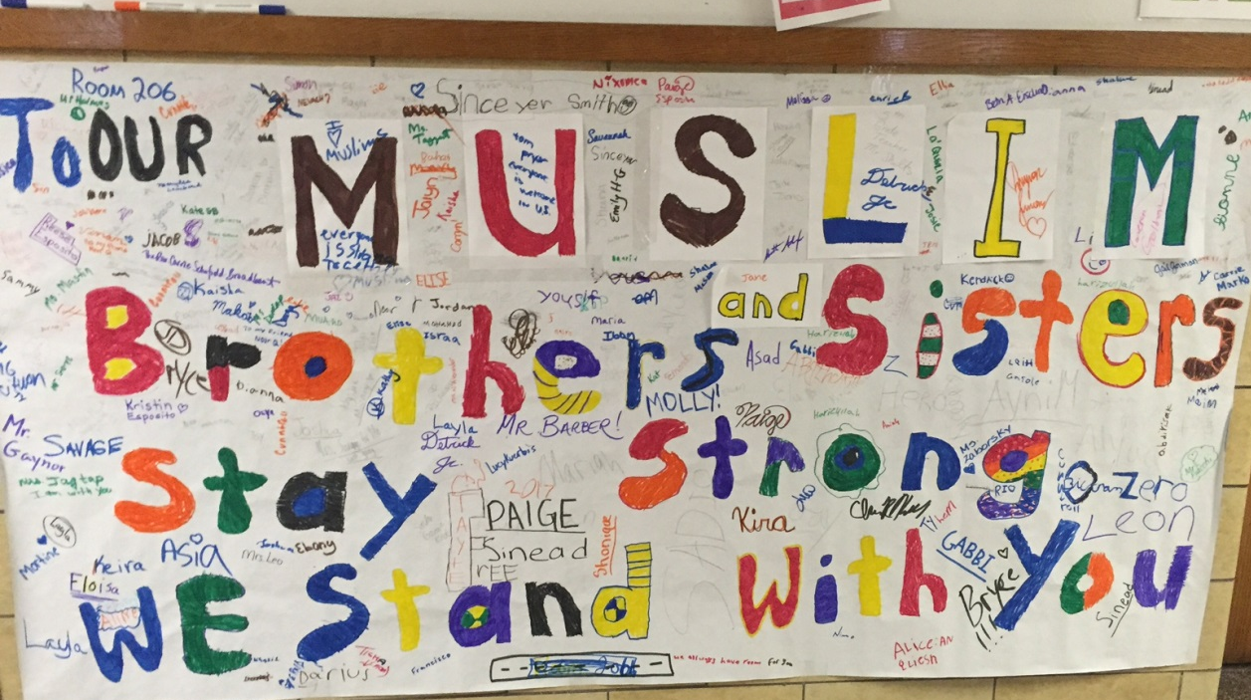
We also toured Ed Smith to see the school. Students noticed this banner and wrote messages on the way by. I am also posting a video of two Danforth scholars, Romeiya and Khadijah, talking about the visit afterward.

